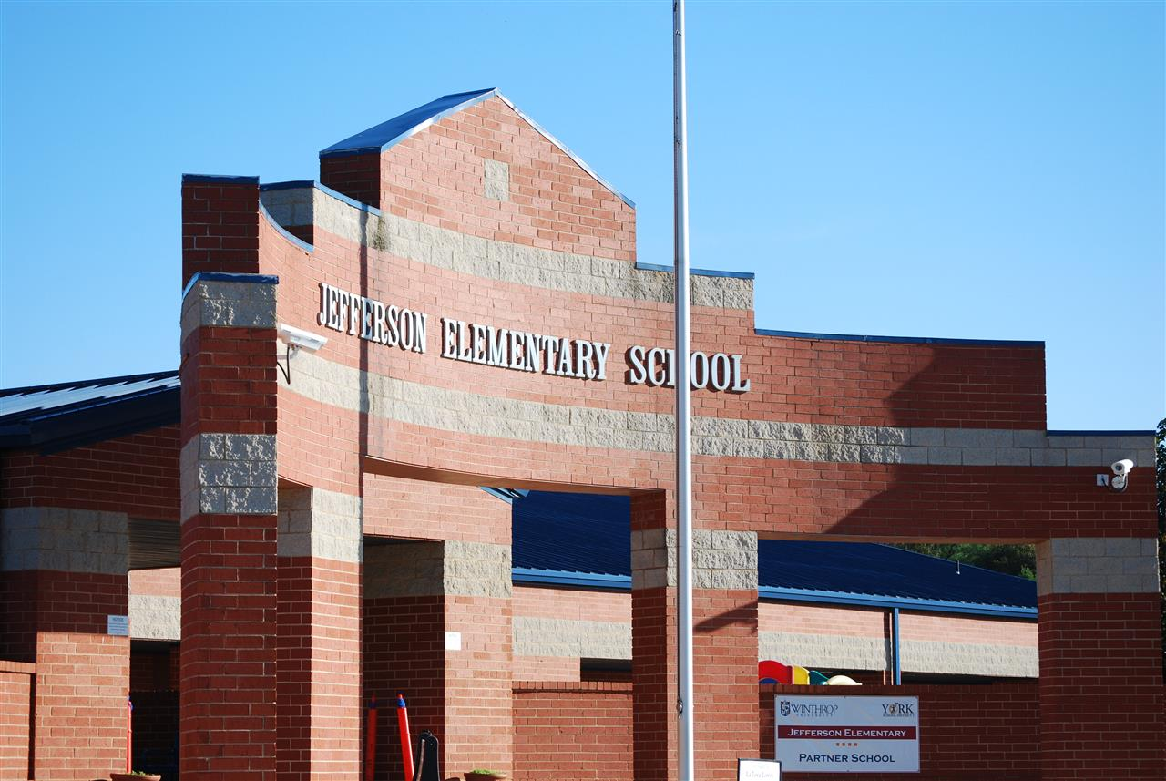

MINIMUM CAPACITY :-

The Minumum intake capacity

of students is between 300-620

children

LIBRARY :-

The Libarary is Available.

CANTEEN:-

The Canteen Facility is Available.

BOARDING :-

No availablility of boarding.

SPORTS :-

There are different categories

sports available.

Girls Volleyball

Boys Volleyball

Football

|  |  |  |
| --- | --- | --- |
| JEFFERSON ELEMENTARY SCHOOL  UTICA - SCHOOL |  |  |
|  |  |  |
| School Detail :- At Jefferson, we are committed to meeting and exceeding state and national academic standards. While encouraging our students to strive to become kind, caring, and compassionate productive members of society.  . While encouraging our students to strive to become kind, caring, |  |